Hunter School Sports Association
Hunter Region Swimming Souvenir Apparel - 2022
Please note that there will NO souvenir apparel sold at the Secondary Hunter Region Swimming Carnivals due to Departmental COVID guidelines.
Therefore, please find the list of items that you can pre-order and these items will then be available to collect from your Zone Manager.
Please note that some items are in short supply so please get your order in early. Orders will be filled according to when they are received and payment is confirmed.
ITEM | PRICE | SIZES |  |  |  |  |  |  |  |  | QUANTITY | TOTAL
Cap  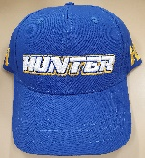 | $20.00
Hoodie  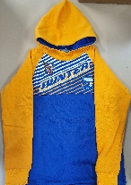 | $50.00 | C10 | C12 | XS | S | M | L | XL | XXL | XXXL
Socks – Anklet  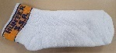 | $10.00 | 2-7 | 7-11 | 11-14
Socks – Sports  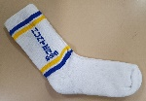 | $10.00 | 2-7 | 7-11 | 11-14
Towel  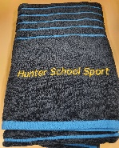 | $30.00

Please ensure your items are paid for AND a copy of this form is emailed to the Hunter School Sports Association (huntersport@det.nsw.edu.au) by Friday 11 March 2022. Please do not send this order form to your child’s school. Orders received after this date will be posted out following the carnival.
Please pay by direct deposit to:
Account: Hunter School Sports Association
BSB: 062 815
Account No: 00907163
Reference: SSWIM – (YOUR CHILD’S NAME) – eg: SSWIM – SMITH, J
Child’s Name:
School:
Zone: Parent Phone contact:
Home/Postal Address:
Deposit Receipt No.: _____________________ Date Deposited: _____________ Amount:

